SQL Queries

# 1. Find the names of all the chimpanzees in the zoo:

Query: SELECT An_name, Chosen_name FROM `animal` WHERE An_name = 'Chimpanzee';

Result:

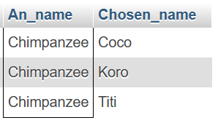

# 2. Find the names of all zookeepers who make more than $35000:

Query: SELECT FName, LName, Salary FROM `zookeeper` WHERE Salary > 35000;

Result:

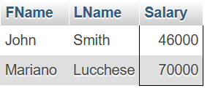

# 3. Find the names of all zookeepers who do not manage an exhibit:

Query:

SELECT ZK_id, Fname, LName FROM `zookeeper` WHERE ZK_id NOT IN (SELECT assigned.Zkeep_id FROM assigned);

Result:

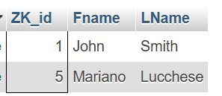

# 4. Find the average salary of zookeepers:

Query: SELECT AVG(SALARY) FROM `zookeeper`;

Result:

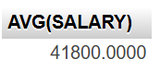

# 

# 

# 5. Display all animals in ascending alphabetical order by their given names:

Query: SELECT Chosen_name FROM `animal` ORDER BY Chosen_name ASC;

Result:

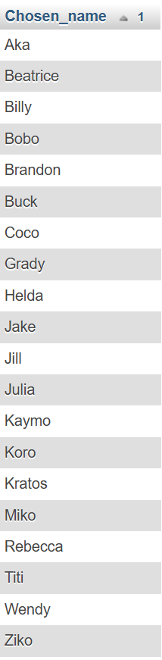

# 6. Return the name, chosen name, exhibit number, and exhibit name of each animal in the zoo:

Query:

SELECT An_name, Chosen_name, animal.Exhbt_num, exhibit.Exhbt_name FROM `animal` JOIN exhibit ON animal.Exhbt_num = exhibit.Exhbt_num;

Result:

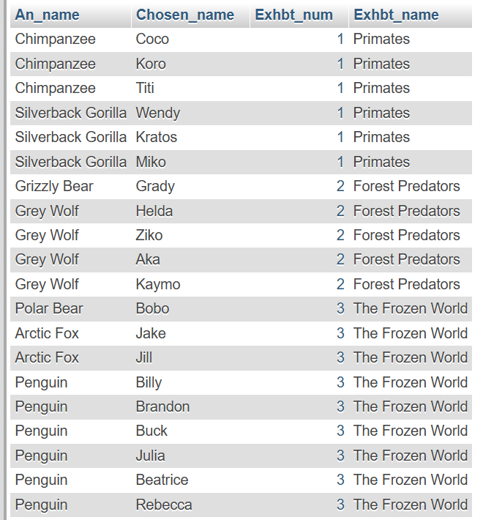

# 7. List the number of animals each exhibit manager manages, excluding any exhibits with less the 6 animals:

Query:

SELECT COUNT(Animal_id), Zkeep_id FROM assigned GROUP BY Zkeep_id HAVING COUNT(Animal_id) > 5;

Result:

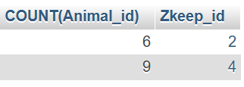

# 8. Find all the chosen names of animals not in the Primate exhibit:

Query:

SELECT Chosen_name FROM `animal` WHERE Exhbt_num > 1;

Result:

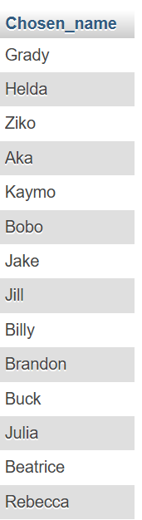

# 9. Find the animal named “Kaymo” and return the name of the exhibit:

Query:

SELECT Chosen_name, exhibit.Exhbt_name FROM `animal` JOIN exhibit ON animal.Exhbt_num = exhibit.Exhbt_num WHERE Chosen_name = "Kaymo";

Result:

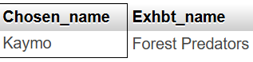

# 10. Return the names and IDs of all the penguins:

Query:

SELECT An_id, Chosen_name FROM `animal` WHERE An_name="Penguin";

Result:

